**SERVICE MANAGEMENT SYSTEM  
LOGISTICS**   
(**PROCUREMENT, WAREHOUSING, ASSET MANAGEMENT, PROJECT MANAGEMENT, VENDOR PORTAL, FLEET MANAGEMENT, AUDIT MANAGEMENT, VEHICLE RESERVATION, MAINTENANCE, REPAIR, AND OVERHAUL**)

A Project Study  
Presented to the IT Project Evaluation Committee  
Bestlink College of the Philippines  
Quezon City, Philippines  
in Partial Fulfillment of the Requirements for the Degree  
Bachelor of Science in Information Technology  
By

Marc Julius M. Barcinal

Romel B. Cabiling

Eunique Lambert L. Malang

Ronalyn M. Ramos

Fridalyn T. Lesigues

April 2022

# DECLARATION

I certify that this project study does not incorporate, without acknowledgment, any material previously submitted for a degree or Diploma in any University, and to the best of my knowledge and belief, it does not contain any material previously published or written by another person or myself except where due reference is made in the text. I also hereby give consent for our Project Study, if accepted, to be made available for photocopying and for inter-library, and for the title and summary to be available to outside organizations.

|  |  |
| --- | --- |
| Signature of Group/Individual Date: | May 20, 2022 |

|  |  |  |
| --- | --- | --- |
| Marc Julius M. Barcinal | Romel B. Cabiling | Eunique Lamber L. Malang |
| Ronalyn M. Ramos |  | Fridalyn T. Lesigues |

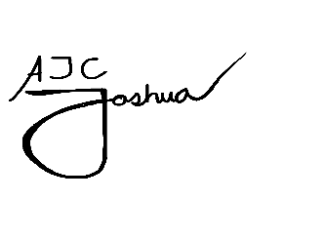Countersigned By:

______________________________ Date: ________________

|  |  |
| --- | --- |
| **Mr. Khristian Hosena**  Project Adviser |  |

# APPROVAL SHEET

This Project Study entitled ***SERVICE MANAGEMENT SYSTEM LOGISTICS (PROCUREMENT, WAREHOUSING, ASSET MANAGEMENT, PROJECT MANAGEMENT, VENDOR PORTAL, FLEET MANAGEMENT, AUDIT MANAGEMENT, VEHICLE RESERVATION, MAINTENANCE, REPAIR, AND OVERHAUL)*** prepared and submitted by MARC JULIUS M. BARCINAL, ROMEL B. CABILING, EUNIQUE LAMBER L. MALANG, RONALYN M. RAMOS, and FRIDALYN T. LESIGUES in partial fulfillment of the requirements for the degree **BACHELOR OF SCIENCE IN INFORMATION TECHNOLOGY** has been examined and recommended for **Oral Examination.**

|  |  |
| --- | --- |
|  | **KHRISTIAN M. HOSENA**  Project Adviser |

**THESIS REVIEW PANEL**

Approved by the Committee on Oral Examination with the grade of ____.

|  |  |
| --- | --- |
| **ENGR. JUNNEL E. AVESTRO, MIT**  Member | **MR. VINCENT CARLO T. GARADOS**  Member |
| **MR. ROMMEL J. CONSTANTINO, MSIT**  Chairperson | |

Accepted and approved in partial fulfillment of the requirements for the degree of Bachelor of Science in Information Technology.

|  |
| --- |
| **ROSICAR E. ESCOBER, Ph.D.**  Dean, College of Computer Studies |
| Date of Final Defense: May 27, 2022 |

**CERTIFICATE OF ORIGINALITY**

This is to certify that the research work presented in the Project Study entitled **SERVICE MANAGEMENT SYSTEM – LOGISTICS (PROCUREMENT, WAREHOUSING, ASSET MANAGEMENT. PROJECT MANAGEMENT, VENDOR PORTAL, FLEET MANAGEMENT, AUDIT MANAGEMENT, VEHICLE RESERVATION, MAINTENANCE, REPAIR AND OVERHAUL)** for the degree Bachelor of Science in Information Technology at the Bestlink College of the Philippines embodies the result of original and scholarly work carried out by the undersigned. This Project Study does not contain words or ideas for the published sources nor written works that have been accepted as basis for the award of a degree from any higher education institution, except where proper referencing and acknowledgement were made.

Researcher:

|  |  |  |
| --- | --- | --- |
| Marc Julius M. Barcinal | Romel B. Cabiling | Eunique Lamber L. Malang |
| Ronalyn M. Ramos |  | Fridalyn T. Lesigues |

April 2022

# ACKNOWLEDGEMENT

The researchers would like to express their profound gratitude to the following people for their valuable contribution that helped in the completion of this study:

**Dr. Mary M. Vicente**, President of Bestlink College of the Philippines, we extend our gratitude for the guidance and for providing us with quality education.

**Dr. Charlie I. Cariño**, Executive Vice President of Bestlink College of the Philippines, we extend our gratitude for making the school a second home for students helping them to learn and gain knowledge.

**Engr. Doni T. Lleno**, Vice President for Administration, we extend our gratitude for building a strong foundation and ensuring that a school is a place for learning.

**Dr. Thelma Villaluna**, OIC for Research, Bestlink College of the Philippines, we extend our gratitude for giving us proper education to enhance our skills and helping us to become better students.

**Dr. Rosicar Escober**, Dean of College of Computer Studies Bestlink College of the Philippines, for providing us the study equipment to enhance and improve our skills for our career.

**Mr. Rommel Constantino**, Program Head of College of Computer Studies, for the constant supervision as well as providing necessary information regarding the project and also for his support in completing this Project;

**Mr. Enrico Pineda**, Capstone professor, for giving us ideas and suggestions to improve our research and sharing his experience for us to have insights to develop our knowledge further.

**Mr. Jorge Lucero**, Capstone professor, for guiding us and providing the necessary connection for those people that we need to provide all the requirements need for this project.

**Mr. Khristian Hosena**, Capstone adviser, for giving us all of his attention and guidance towards the succession of this project.

**Ms. Evelyn Herrera** Class Adviser, for her excellent advisory and giving us her time to communicate with other professors.

**Almighty God,** for everything He provided for us, giving us another day to live to enjoy life and making us safe through the pandemic and every day.

# DEDICATION

The researchers wholeheartedly dedicate this humble

piece of the work to GOD and the researcher family,

relatives, friends ‘colleagues, and to the people

whose name are too many to mention,

for their consistent help and support

that has been the source of us

strength and inspiration to

pursue our endeavor.

# ABSTRACT

|  |  |
| --- | --- |
| Title | **SERVICE MANAGEMENT SYSTEM: (*PROCUREMENT, WAREHOUSING, ASSET MANAGEMENT, PROJECT MANAGEMENT, VENDOR PORTAL, FLEET MANAGEMENT, AUDIT MANAGEMENT, VEHICLE RESERVATION, MAINTENANCE, REPAIR AND OVERHAUL*)** |
| Authors | **MARC JULIUS M. BARCINAL**  **ROMEL B. CABILING**  **EUNIQUE LAMBERT L. MALANG**  **RONALYN M. RAMOS**  **FRIDALYN T. LESIGUES** |
| Degree | **BACHELOR OF SCIENCE IN INFORMATION TECHNOLOGY** |
| Major/s | **INFORMATION MANAGEMENT, INFORMATION SECURITY, NETWORK ADMINITRATOR** |
| Date of Completion |  |

As Sun Tzu has said, “The line between disorder and order lies in logistics…” that’s because logistics plays a critical role in an organization especially nowadays. The logistics is all about efficiently managing the company’s resources as it affects all other departments and influences the company’s overall performance. But even to this day, the management of logistics here in the Philippines is still being processed manually according to the latest white paper published by YCP Solidiance titled “Digitalization in the Philippine Logistics Industry”. This poses a threat to the data security and data integrity of the system which could then lead to many management problems such as, misplacement or lost of records, unreliability of documents, absence of backup files in case disasters, etc. The proponents propose the development of Tech-Trendz Services (Logistics), a web-based service management system that features a centralized network all across every departments in a company. This system solves the key problems about data security and data integrity; it also provides features that will help the user reduce their workloads and time consumed on management process.

The proponents used the agile methodology to break down the development of the system into small task. These small tasks are then arranged based on their importance and priority on several continuous iterations of development cycles that lasts every fortnight called sprints. Each sprint is like a small development life cycle as is also follows the basic analysis, design, testing, and implementation procedures. After finishing a sprint, the development team presents it to the project stakeholders for consultation. The stakeholders should be heavily involved during the whole development process, as they provide feedbacks after each delivery of completed sprints for the continuous improvement of the product. These collaboration between the development team and project stakeholders will occur several times on the development process until the product is completed. The proponents found it easier to use this method as it divides what is supposed to be a big project in to smaller task that can be developed with more focus and potential for improvement. The agile method ensures that the final product will be high quality and satisfactory to the clients as their requirements are consulted and implemented all throughout the development process.

# Table of Content

DECLARATION 2

APPROVAL SHEET 3

ACKNOWLEDGEMENT 5

DEDICATION 7

ABSTRACT 8

Table of Content 11

1. Project Management 21

1.1 Business Case 21

1.1.1.1 Executive summary 21

1.1.1.2 Business case analysis team 23

1.1.1.3 Problem definition 26

1.1.1.4 Project Overview 28

1.1.1.5 Strategic Alignment 35

1.1.1.6 Cost-benefit analysis 36

1.1.1.7 Approvals 37

1.1.2 Project charter 38

1.1.3 Stakeholder Strategy 38

1.1.3.1 Introduction 38

1.1.3.2 Identify stakeholders 38

1.1.3.3 Key stakeholders 39

1.1.3.4 Stakeholder analyst 40

1.2 Project Planning 41

1.2.1 Project management plan 41

1.2.1.1 Introduction 41

1.2.1.2 Project management approach 42

1.2.1.3 Project scope 43

1.2.1.4 Milestone list 46

1.2.1.5 Schedule baseline and WBS 47

1.2.1.6 Change management plan 48

1.2.1.7 Communication Management Plan 50

1.2.1.8 Cost management plan 50

1.2.1.9 Procurement Management Plan 51

1.2.1.10 Project scope management plan 51

1.2.1.11 Schedule management plan 51

1.2.1.12 Quality management plan 53

1.2.1.13 Risk management plan 54

1.2.1.14 Risk Register 55

1.2.1.15 Staffing Management Plan 56

1.2.1.16 Cost Baseline 56

1.2.1.17 Quality Baseline 57

1.2.2 Risk management plan 57

1.2.2.1 Introduction 57

1.2.2.2 Top three risk 58

1.2.2.3 Risk management approach 59

1.2.2.4 Risk identification 59

1.2.2.5 Risk Qualification ad Prioritization 59

1.2.2.6 Risk Monitoring 60

1.2.2.7 Risk Mitigation and Avoidance 61

1.2.2.8 Risk Register 61

1.2.3 Scope management plan 62

1.2.3.1 Introduction 62

1.2.3.2 Scope management approach 63

1.2.3.3 Roles and responsibilities 64

1.2.3.4 Scope definition 67

1.2.3.5 Project scope statement 67

1.2.3.6 WBS 69

1.2.3.7 Scope verification 69

1.2.3.8 Scope control 70

1.3 Project Execution plan 71

1.3.1 Implementation and migration plan 71

1.3.1.1 Purpose 71

1.3.1.2 Description of implementation 71

1.3.1.3 Points of contact 72

1.3.1.4 Major task 73

1.3.1.5 Implementation Schedule 75

1.3.1.6 Security 76

1.3.1.7 Implementation Support 76

1.3.1.8 Listing of hardware, software and facilities 77

1.3.1.9 Performance Monitoring 77

1.3.1.10 Implementation Requirements (Hardware/Software/ Personnel/ Facilities/ other capital investment: 78

1.3.1.11 Back Out Plan 79

1.3.1.12 Post Implementation Verification 80

1.4 Project Closure 80

1.4.1 Transition-out plan 80

1.4.1.1 Executive Summary 80

1.4.1.2 Transition Approach 81

1.4.1.3 Transition Team Organization 81

1.4.1.4 Work Transition 83

1.4.1.5 Work Execution during Transition 83

1.4.1.6 Subcontracts 84

1.4.1.7 Property Transition 84

1.4.1.8 Knowledge Transfer 87

1.4.1.9 Schedule 88

1.4.1.10 Handover and Acceptance 88

1.4.2 Project acceptance 88

1.4.3 Post project review 90

1.4.3.1 Project Summary 90

1.4.3.2 Project Costs 93

1.4.3.3 Project Schedule 94

1.4.3.4 Recommendations 95

1.5 Technical solution design 96

1.5.1 Project Information 96

1.5.2 Executive Summary 97

1.5.3 Requirement Definition 97

1.5.4 Solution Description 97

1.5.4.1 Logical Architecture 97

1.5.4.2 High-Level Architecture 97

1.5.4.3 Process Flow 97

1.5.5 Implementation Timeline 97

1.6 System architecture 97

1.6.1 Business Process Architecture 97

1.6.2 Application Architecture 104

1.6.3 Data Architecture 105

1.6.4 Technology Architecture 106

2. Product Backlog 113

2.1 Product backlog (user stories) Table 113

2.2 Product Backlog for EIS Information Security 137

2.3 Product Backlog for EIS Standards 139

2.1.1 UI/UX (Icons, color, etc.) 140

2.4 Product Backlog for integration 143

2.5 Product Backlog for analytics 145

2.1.2 Application System Analytics 145

2.1.3 EIS Analytics 145

3. Sprint backlog 145

3.1 Sprint backlog table 145

3.1.1 User stories 145

3.1.2 Information security 145

3.1.3 EIS standard 145

3.1.4 EIS integration 145

3.1.5 Analytics 145

3.2 Sprint Burndown Chart 145

3.2.1 Sprint Backlog 145

4. EIS Implementation Model 145

4.1 Information and Data Management 145

4.1.1 Data Integration Model 145

4.1.2 Data Migration Strategies 145

4.1.3 Data Analytics (Business Intelligence Framework) 145

4.1.4 Privacy and Security 145

4.1.5 Backup, Retention, and Disposal 145

4.2 Information Security 145

4.2.1 Physical Security 145

4.3 Network Design and implementation Model 146

4.3.1 Design Architecture 146

4.3.2 implementation Framework 146

*5.* Conclusion and Recommendations 146

Appendices: 146

Appendix A Detailed System Architecture/ Reference requirements 146

A.1 Business Process Architecture (Business Process Model) 146

A.2 Application Architecture 146

A.3 Data Architecture 147

A.4 Technology Architecture 147

Appendix B Deployment Diagram 147

Appendix C Adviser Acceptance (Functional) 147

Appendix D Sprint Burndown Charts (per sprint) Signed by the adviser 147

Appendix D.1 Individual burndown charts per member 147

Appendix B Deployment Diagram 147

Appendix E Requirements Traceability Matrix (PB, Test Scenarios, status 147

Appendix F Panel Evaluation and Signature (Plus photo ops during defense) 147

Appendix G Pilot Companies Background with proofs of interviews 147

Appendix H USB Copy of the codes (reliable USB) 147

Appendix I IMRAD Format Summary 147

Appendix J Comparison of the EIS to existing EIS’s (5 Pages) 147

Appendix K Operation Manual (10 Pages max, 5 Pages min) 147

3.2.2 147

**List of Tables**

Table 1: Business case analysis team 25

Table 2: Goals and Objectives 30

Table 3: Project Performance 31

Table 4: Milestone and Deliverables 34

Table 5: Strategic Alignment 35

Table 6: Cost-benefits Analysis 37

Table 7: Approvals 37

Table 8: Milestone List 47

Table 9: Cost Baseline 57

Table 10: Top Three Risks 59

Table 11: Scope Management Approach Roles and Responsibilities 67

Table 12: Points of Contacts 73

Table 13: Implementation Schedule 75

Table 14: Transition Team Organization 83

Table 15: Subcontracts 84

Table 16: User Accounts and Password 87

Table 17: Project Team and Staffing 91

Table 18: Project Costs 94

Table 19: Project Schedule 95

Table 20: Project Information 96

Table 21: Technology Architecture 112

Table 22: Product Backlog (User Stories) Table 137

Table 23: Product Backlog EIS Information Security 138

Table 24: Product Backlog for EIS Standard 140

Table 25: UI/UX (Icons, Color, ETC.) 143

Table 26: Product Backlog for Integration 144

**List of Figures**

Figure 1: Stakeholder's Analysis 41

Figure 2: Work Breakdown Structure 69

Figure 3: BPA Top Level 1 97

Figure 4: BPA Top Level 2 Logistics 98

Figure 5: BPA Top Level 3 Procurement 99

Figure 6: BPA Top Level 3 Warehousing 99

Figure 7: BPA Top Level 3 Asset Management 100

Figure 8: BPA Top Level 3 Project Management 101

Figure 9: BPA Top Level 3 Vendor Portal 101

Figure 10: BPA Top Level 3 Fleet Management 102

Figure 11: BPA Top Level 3 Audit Management 102

Figure 12: Vehicle Reservation 103

Figure 13: BPA Top Level 3 Maintenance Repair and Overhaul 103

Figure 14: Application Architecture 104

Figure 15: Data Architecture 105

# Project Management

## Business Case

### Executive summary

Tech-Trendz Services is a Service Management System that uses a huge number of modules to cover almost all aspects of a service-providing company. It is a web-based system that features a centralized network all across the company. It gives importance to data integrity, which is a key factor for the system to be semi-automated, which then helps the users reduce their workload.

Logistics is the detailed process of planning and carrying out an operation. When it comes to business, that process refers to the flow of work from beginning to conclusion in order to meet organizational expectations. The logistics system of Tech-Trendz Services assists the company in reducing the workload and managing the workflow more effectively.

#### Issue

Many people's health, as well as their employment, was harmed by the pandemic. COVID-19 had a severe influence on employment in the Philippines, with the majority of employees reporting job suspensions, reduced hours and compensation, and others being compelled to take unpaid leave. Human Resources at Tech-Trendz will be able to assist them in quickly finding new career prospects.

#### Anticipated Outcomes

The employment agency will be able to cut transaction processing time by using the suggested project since it will have direct access to collected data, track documents, audit, and manage reservations with the swipe of a hand. Reports are also available at any moment. Because records would be immediately accessible in the system, keeping them will no longer be a burden for the employee. Transactions will be easier to complete, and the workload will be reduced.

#### Recommendation

The team can develop and build a better strategy to provide more job possibilities by examining the present employment challenges that many individuals are encountering during this pandemic. It also allows us to develop this suggested Tech-Trendz Services, which will lead to a more effective and efficient employment search.

### Business case analysis team

The business case analysis team consists of five (5) members that are prior set by the Scrum Master. In this section, these individuals are responsible for the development of this project. The names, roles, and descriptions are as follows:

|  |  |  |
| --- | --- | --- |
| **Name** | **Role** | **Descriptions** |
| Mr. Khristian Hosena | Project  Sponsor | * Serves as an ultimate authority / * responsibility for the project * Provides strategic direction and * guidance * Approves changes to the scope * Identifies and secures funding * Makes business/approaches * decisions for the project * Participates in key activities * Makes resources available * Approves work products, address * issues, and approve the change requests |
| Barcinal, Marc Julius | Scrum Master | * Professional in the field of project management. * Responsible for planning, anylyzing, procurement, and execution of a project. * Undertaking that has a defined start and a defined finish |
| Cabiling, Romel | Backend Developer | * Responsible for database development * Responsible for integration of the whole system |
| Malang, Eunique Lambert | System Designer / Front-end Developer | * Responsible for the designing of the UI/UX of the system * Responsible for the branding of the project |
| Ramos, Ronalyn | Front-end Developer | * Responsible for the UI/UX of the system |
| Lesigues, Fridalyn | Documentation / Frontend Developer | * Responsible for the UI/UX of the system * Responsible for the documentation of the project |

Table 1: Business case analysis team

### Problem definition

#### Problem statement

This includes retaining highly skilled workers while improving their performance, intellectual capability, and skill development. Under the current circumstances, employee performance was poorly controlled and monitored. Because they rely solely on recommendations with no supporting evidence, Logistics is having difficulty evaluating employees on a regular basis in order to update their performance and quality of work. Furthermore, the institution is at odds with providing proper pay raises to their employees for the hard work they put in for the organization. Another issue is that the institution is having difficulty selecting individuals for a critical job post that requires an immediate filling, necessitating a thorough review to ensure that institutions have what they require.

#### Organizational Impact

The Tech-Trendz Services will have a wide range of effects. The next section explains how the project's implementation will affect the organization, tools, processes, hardware, software, and roles and responsibilities.

**Tools**: The existing manual system will no longer be used as the project has been implemented. Authorized users will be required to be trained for a new useful tool for a system project.

**Processes**: The Service Management System will make the process easier, for it will lessen the workload and the consumption time for processing the collection of such vehicles the accuracy of the record will be more maintainable and manageable.

**Hardware/Software**: The Service Management will be required to have the workstation that will meet the needs of the following:

**Hardware Minimum Requirements:**

* + - * + 166 MHZ Pentium IV or equivalent
        + 2 GB memory

**Software minimum requirements:**

* + - * + Latest Browser

**Internet Service Provider:**

* + - * + 10 Mbps
        + Unlimited Connections

#### Technology Migration

To effectively transition existing data to a web-based system project, a phased approach has been developed to discuss day-to-day processes.

A high-level overview of the stepwise strategy is provided below.

**Phase I:** Developed a web-based system that will be installed on the workstation and will be tested by our team.

**Phase II**: All Logistics staff will undergo training about the new web-based system implemented

### Project Overview

#### Project description

By developing a web-based logistics system, the Tech-Trendz Logistics system will support the Tech-Trendz Services. This project is a single tool with numerous functions that will be used. With a single-hand movement, the technology in this project will be able to collect and calculate payment. Any date can also be used in reports. Instead of coding it, this project allows you to configure and set up various sorts of records of every transaction by hand, making it easier to transact and reducing workload.

#### Goals and objectives

Tech-Trendz Logistics' aims and objectives are directly supported by the Developed Project. The table below shows which business goals and objectives Service Management supports and how it does so.

|  |  |
| --- | --- |
| **Business Goal/Objective** | **Description** |
| Timely and accurate reporting of data | The system will enable real-time and accurate reporting of all data gathering, as well as a summary of the applicant's data collection. |
| Improve Data Integrity | Changes to Organization Data and Permissions The system will keep track of all transactions. |
| Reduce workload | The system will need to be set up and configured in order to reduce the workload in each transaction. |
| Improve processing time | Rather than writing in processing, the system will just click as you process. |

Table 2: Goals and Objectives

#### Project performance

The table below lists the project's key resources, processes, or services, as well as their performance metrics.

|  |  |
| --- | --- |
| **Key Resource/Process/Service** | **Performance Measure** |
| Reporting | The web-based system will generate and print all collections and deposit them in a desired month of the date |
| Software | Easily to use and transact |
| Transaction log | All transactions done by the user will be logged on the system |
| Staff Resources | Reduce some workloads and less time in doing the workload as several functions will now be automated |

Table 3: Project Performance

#### Project assumption

**PROCUREMENT**

Procurement is used for purchasing and acquiring assets and services to be used within the company.

**WAREHOUSING**  
Warehousing is used for storage and listing of the inventory used within the company.

**ASSET MANAGEMENT**

Asset Management is used for managing and monitoring the assets within the company.

**PROJECT MANAGEMENT**

Project Management is used for the creation of new projects within the company.

**VENDOR PORTAL**

The vendor portal is used for finding cost-friendly suppliers or contractors and is responsible for posting biddings online.

**FLEET MANAGEMENT**

Fleet Management is used to management of fleets or vehicles of any size and type for available and ready to use.

**VEHICLE RESERVATION**

Vehicle Reservation is used for the reservation of a vehicle and transportation for the customer to use.

**MAINTENANCE, REPAIR, AND OVERHAUL**

Maintenance Repair and Overhaul is the one that monitors and is responsible for all vehicles to be used, whether it is working or not.

**AUDIT MANAGEMENT**

Audit Management is the one responsible for audit reports and transactions are done within the company.

#### Project constraints

The following are some potential logistics constraints. More assumptions will be identified and included as project planning progresses.

**Time Constraints:** Refers to the project completion schedule, which includes deadlines for each milestone and the availability of each team member to complete each task.

**Information Constraints:** Due to the pandemic and government protocol to limit the people outside. The project team's resources to support the project are limited.

#### Major project milestones

The project milestones identified at this time are included in the table below. The project milestones and their target completion dates will be amended, adjusted, and finalized as needed to establish the baseline timeline as project planning progresses and schedules are identified.

|  |  |
| --- | --- |
| **Milestone/Deliverable** | **Target Date** |
| Project Charter | TBA |
| Project Plan Review and Completion | TBA |
| Project Kick-Off | TBA |
| Sprint 1 | TBA |
| Sprint 2 | TBA |
| Sprint 3 | TBA |
| Sprint 4 | TBA |
| Sprint 5 | TBA |
| Sprint 6 | TBA |
| Sprint 7 | TBA |
| Sprint 8 | TBA |
| Close Out/Project Completion | TBA |
| Project Charter | TBA |

Table 4: Milestone and Deliverables

### Strategic Alignment

|  |  |  |
| --- | --- | --- |
| **Plan** | **Goals/Objectives** | **Relationship to project** |
| Logistics Strategic Plan for 2022 Information Management | Adopt a systematic approach that will benefit the organization and its department effortlessly. | The new, improved business process will allow Logistics Admin and staff to work efficiently |
| Logistics Strategic Plan for 2022 Transactions | Improve keeping records and make fast transactions | This project will keep records of supplies, vehicles and transaction information, and real-time management information in the agency. |

Table 5: Strategic Alignment

### Cost-benefit analysis

The table below summarizes the cost and savings actions of the Logistics project, as well as their descriptions and the costs or savings associated with them throughout the year. The net savings for the project year are shown at the bottom of the chart.

|  |  |  |  |
| --- | --- | --- | --- |
| **Action** | **Type** | **Description** | **First Year Cost** |
| Development of the Project | Cost | The ongoing process of development of the project | ₱ 20,000.00 |
| Purchase web server and domain | Cost | The initial investment for the development of Tech-Trendz Services | ₱ 10,000.00 |
| Subscribe to Internet provider | Cost | The system will require to stay connected to the Internet to function | ₱ 10,000.00 |
| Stakeholder’s Training | Savings | The development team will train the user to use the system | ₱ 10,000.00 |
| Estimate Cost:………………………………………………..₱ 40,000.00  Estimate Savings:……………………………………………₱ 10,000.00  Total Cost:……………………………………………………₱ 10,000.00 | | | |

Table 6: Cost-benefits Analysis

### Approvals

The signatures of those listed below indicate that they understand the purpose and content of this Business Case. By signing this document, you indicate that you approve of the proposed project outlined in this business case and that the next steps in creating a formal project in accordance with the details outlined herein may be taken.

|  |  |  |  |
| --- | --- | --- | --- |
| **Approver Name** | **Title** | **Signature** | **Date** |
| Khristian Hosena | Project Sponsor |  |  |
| Jorge Lucero | Process Improvement |  |  |

Table 7: Approvals

## Project charter

This charter formally authorizes the Tech-Trendz project to develop a Services Management System for Bestlink College of the Philippines. A project plan will be developed and submitted for approval to the Project Sponsor. The scope statement; schedule; cost estimate; and provisions for scope, resource, schedule communications, quality, risk, stakeholder management, and project control will all be included in the project plan. The Project Sponsor, Mr. Khristian M. Hosena, will assign all resources.

The goal of Tech-Trendz Services is to make it simple to manage transactions in agencies. The project deliverables must include the design of the agency's system, all coding, testing, and implementation. The service management system's goals are to speed up agency transaction services, track documents and easily report on them, automatically count supplies, and provide reports. High-level risks for this project include ensuring that implementation is completed without interfering with ongoing agency operations and that there are no problems migrating collection files from the legacy system to the system. The Project Sponsor will determine success once the system has been implemented and one full transaction cycle has been completed with no discrepancies that meets the objectives.

The Scrum Master Marc Julius Barcinal is hereby authorized to interface with management as needed, negotiate for resources, delegate responsibilities within the framework of the project, and communicate with all contractors and management as needed to ensure the project's successful and timely completion. The Project Manager is in charge of developing the project plan, monitoring the project's schedule, cost, and scope during implementation, and maintaining project control by measuring performance and taking appropriate action.

## Stakeholder Strategy

### Introduction

The Tech-Trendz Stakeholder Management Strategy will identify and classify the project's stakeholders. This will aid in determining the stakeholders' impact and interests. It will also be aware of the methods and techniques for approaching or communicating with stakeholders. As a result, the project will be able to receive feedback on its development openly.

### Identify stakeholders

A meeting of the Tech-Trendz Scrum Team will be held in order to identify project stakeholders. The principal project team and the project sponsor will attend this meeting. Managers, department personnel, the development team, and any other employee who may be touched by the Tech-Trendz Human Resource are examples of stakeholders.

The following factors will be used to establish whether or not a person is a stakeholder:

1. Will this project have a direct impact on the person or their organization?
2. Will the person or their organization be in a position to affect the outcome?
3. Will the individual have an impact on project resources (materials, personnel, and funding)?
4. Will the individual possibly gain from the project?
5. Stakeholders are defined as those who match one or more of the aforementioned criteria.

### Key stakeholders

The scrum team will identify the key stakeholders who will be affected by this project and have the most effect. The persons who are most important to the project's success are called key stakeholders. Once the key stakeholders have been identified, the project manager will devise a strategy to collect their ideas, concerns, and other forms of involvement in the project.

The scrum team will include key stakeholders in every project meeting by analyzing. Sessions or any other deliverables are effective. It will be accomplished via communicating with important stakeholders. Ensure that all complaints are addressed.

### Stakeholder analyst

The goal of this analysis is to determine the level of influence or role of the stakeholders. It is to understand the optimal level or method for each important stakeholder's participation. Stakeholders will be classified by the scrum team according to their organization or department. The project team will use a power/interest matrix to categorize all stakeholders after they have been identified.

To show the probable impact of each participant on the project, the project team will also construct a stakeholder analysis matrix based on this analysis, which will show each stakeholder's issues, level of involvement, and management plan.

|  |  |  |  |
| --- | --- | --- | --- |
| **Key** | **Organization** | **Power 1-5** | **Interest 1-5** |
| A | CEO | 5 | 5 |
| B | Administrator | 4 | 5 |
| C | Investors | 3 | 3 |
| D | Contractors | 2 | 3 |
| E | Users | 1 | 2 |

Table 8: Stakeholder's Analysis

Below is the power/interest chart for the Cashiering Project stakeholders. Each letter represents a stakeholder in accordance with the key in the chart above.

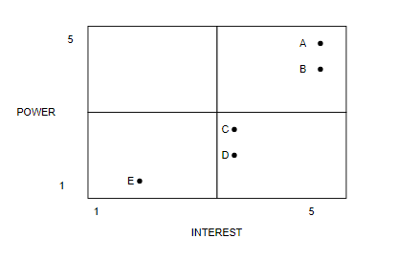

Figure : Stakeholder's Analysis

# Project Planning

## Project management plan

### Introduction

Managing a project is a difficult task, regardless of its size or scope. Everything from planning the smallest details to meeting clients' ever-changing requests to delivering projects on time can go wrong.When you break the project into reasonable stages, each with its own goals and deliverables, it’s easier to govern the project and the quality of the product. If you are in a position where you are required to manage projects for your firm and are feeling overwhelmed, start learning the basic stages of the project life cycle phases, according to a project management handbook.

### Project management approach

The Scrum Master, Barcinal Marc Julius, is hereby authorized to interface with management as needed, negotiate for resources, delegate responsibilities within the project framework, and communicate with all project team members and management as needed to ensure the project's success and timely completion. All project and company management strategies will be examined and approved by the product owner. The scrum team will report on their progress throughout the project. The Project Manager is also in charge of keeping the scrum team informed about their progress and project results.

### Project scope

**Procurement**

It is the process of purchasing products or services and is frequently in reference to company spending. Preparation, solicitation, and payment processing are all aspects of business procurement, and they frequently include numerous departments within an organization.

**Warehousing**

Warehouses store and protect products safely and securely in an organized manner, making it easy to track an item's location, when the item arrived, how long the item has been there, and the number of items on hand.

**Asset Management**

Refers to the cost-effective process of developing, operating, maintaining, and selling assets. The term is most commonly used in finance to refer to individuals or firms who manage assets on behalf of individuals or other entities.

**Project Management**

To create a specific plan for a project. To create a timeline for the project plan. The project schedule is being monitored.

**Vendor Portal**

It's also known as a Supplier Portal; it's a web-based platform that allows you to engage with vendors and suppliers in real-time. The vendor portal allows you to find a supplier for a common supply that the company requires.

**Fleet Management**

It is a management strategy that helps businesses to arrange and coordinate work vehicles in order to increase efficiency and lower costs. Fleet management includes following and recording mechanical diagnostics, albeit it is most typically used for vehicle tracking.

**Audit Management**

It is recording transactions and adhering to internal control policies and procedures, as well as ensuring that board-approved audit directives are followed. It makes the audit workflow and collaboration process more efficient and organized.

**Vehicle Reservation System**

To reserve a vehicle from fleet management that the supplier selects and to track where the vehicle goes and where it arrives.

**Maintenance Repair and Overhaul**

Have scheduled maintenance to organize the task and preventive maintenance has able to monitor the mileage in order to set change the oil for the vehicle. The system has a repair history of reviewing the previous transaction of maintenance or repair.

### Milestone list

The important milestones for the Service Management System are listed in the table below. Only significant project milestones such as project phase completion and gate review are included in this table. Smaller milestones may not be seen on this table, but they are incorporated into the project schedule and work breakdown structure. If a scheduling delay threatens a milestone or delivery date, the project manager must be notified as soon as possible so that proactive measures can be taken to avoid date slips. The project manager will notify the project team of any approved changes to these milestones or dates.

|  |  |  |
| --- | --- | --- |
| Milestone | Description | Date |
| Requirements Gathering | All Requirements for Tech-Trendz must determine to base design upon | TBA |
| Designing | To design for the software. This the theoretical | TBA |
| Developing | All coding was completed resulting in a software prototype. | TBA |
| Testing and Debug | All functionally tested and all identified errors corrected | TBA |
| Transition of system | Completed software and documentation transitioned to operations group to begin production. | TBA |

Table 9: Milestone List

### Schedule baseline and WBS

The WBS for Tech-Trendz Logistics is made up of work packages that have been assigned a specific amount of time to complete by the scrum team. With input from functional managers and research from previous projects, work packages were designed through close collaboration among scrum team members and stakeholders. All work packages for Tech-Trendz are listed in the WBS Dictionary. These consist of Tasks, resources, and deliverables are all included.

The WBS and Project Charter were used to create the Tech-Trendz timeline, which included input from all project team members. The project sponsor reviewed and approved the timetable. The Scrum Master will keep track of the schedule. Any planned timetable adjustments will require the project sponsor's permission. The impact of the modification on the schedule, cost, resources, scope, and risks will be determined by the Scrum Master and team. If the Project Sponsor approves the change, it will be implemented by the Scrum Master, who will update the schedule and related documentation, as well as notify all stakeholders.

### Change management plan

The following steps comprise the Tech-Trendz Human Resource change control process for the project and will be utilized on the Logistics project:

Step #1: Identify the need for a change (Any Stakeholder)

*The requestor will submit a completed change request form to the project manager.*

Step #2: Log change in the change request registers (Scrum Master)

*The project manager will maintain a log of all change requests for the duration of the project.*

Step #3: Conduct an analysis of the change (Scrum Master, Scrum Team, Requestor)

*The scrum master will conduct an evaluation of the impact of the change to cost, risk, schedule, and scope.*

Step #4: Submit a change request to (Scrum Master)

*The scrum master will submit the change request and analysis to all the project team and stakeholders*.

Step #5: Scrum team and stakeholder decision

*The Scrum Master will discuss the proposed change and decide whether it will be approved based on all submitted information*.

Step #6: Implement change (Scrum Master)

When the changes are approved by the project owner, team, and stakeholders, the Scrum master will update and set new guidelines for project documentation as necessary to ensure any changes are clear to the team and stakeholders. If a change is approved by the scrum team and stakeholders, the project manager will update and re-baseline project documentation as necessary, as well as ensure any changes are communicated to the team and stakeholders

### Communication Management Plan

### Cost management plan

The Scrum Master will be responsible for identifying and tracking project costs throughout its lifecycle. The Scrum Master will present and audit the project's Cost and timeline at the review. The Scrum Master is in charge of cost variances and providing to the Project Sponsor solutions for getting the project back on track using earned value estimates. The logistical Project Sponsor has full financial and decision-making authority, including the ability to adjust the budget.

### Procurement Management Plan

All procurement activities under this project will be managed by the Scrum Master. All procurement actions up to ₱5,000 must be approved by the Scrum Master. The Project Sponsor must approve any procurement actions that exceed this amount.

### Project scope management plan

The Project Sponsor must formally acknowledge the project's final product. This permission is conditional on a thorough review of all project documentation, testing results, early access study findings, and the completion of all tasks/work packages and product functionality.

The Scrum Master, stakeholders, or any scrum team member can suggest scope adjustments. All change requests will be sent to the Scrum Master, who will assess the project's requested scope.

### Schedule management plan

The Service Management System will use PHP and Laravel to generate project schedules. The Work Breakdown Structure established the timeline and deliverables (WBS). All activities have been described in order to identify specific tasks that must be completed in order to complete all deliverables.

Following the creation of the schedule, the project team will review it, and any assigned project tasks will be tracked. The work package assignments, durations, and timetable for the project must be agreed upon by the project's team and resources. When this is completed, the project sponsor will evaluate and approve the schedule, and it will become the baseline. In accordance with Service Management organizational standards, the following milestones must be identified for all project timelines:

* + - * Completion of scope statement and WBS
      * Base lined project schedule
      * Approval of final project budget
      * Approval of roles and responsibilities
      * Requirement’s definition approval
      * Project implementation
      * Acceptance of final deliverable

### Quality management plan

Logistics project team members will collaborate on quality management from individual work packages to final project deliverables. The team must ensure that everything meets an acceptable standard. The Logistics quality roles and responsibilities are as follows. The Project Owner is in charge of verifying all quality standards for the Logistics as well as ensuring that all project activities and deliverables meet the specified and approved quality standards.

Quality control is the responsibility of the Project Manager. The Project Manager is in charge of carrying out the Quality Management Plan and ensuring that all activities, processes, and documentation are included. The Project Manager will monitor all deliverables to ensure that acceptable quality standards are met. The Project Manager is also in charge of informing and monitoring the project team and stakeholders about all quality standards.

The project team and stakeholders will work with the Project Manager to develop acceptable quality standards. They will also ensure that all quality standards are met and that any quality issues are reported to the Project Manager.

The Logistics project meets delivery objectives and expectations while also establishing a structured procedure for measuring and accepting quality standards. A quality control project will require the use of tools and procedures.

If changes are proposed and approved, the Project Manager is also responsible for informing the project team of the changes and revising all project plans and documentation.

### Risk management plan

The method we used to identify and manage risks for this project has had a significant impact on its development. The scrum team will put effort into identifying risks associated with this project, as pooling all of its resources and recognizing risks early on allows the project team to design a strategy for addressing the risks.

After obtaining data, we run into roadblocks in developing the project, which determine the project's risk. To address and find a solution, the scrum master will assess it and convey it to the scrum team and stakeholders.

### Risk Register

This project's Risk Register is a chronicle of all recognized risks, their likelihood, impact on the project, their type, mitigation method, and when the risk will occur. The register was prepared during the project manager's inaugural project risk management meeting. The project team identified and classified each risk at this discussion. In addition, the team assigned a score to each risk based on the likelihood of it occurring and the potential consequence. The Risk Register also includes each risk's mitigation method as well as when the risk is most likely to occur. Based on the risks and timelines indicated, Each risk has been included in the project plan in the risk register. The scrum master will appoint a risk manager at the appropriate period in the plan—prior to when the risk is most likely to occur—to ensure adherence to the agreed-upon mitigation strategy.

### Staffing Management Plan

### Cost Baseline

All budgeted expenditures for the successful completion of the Logistics Project are included in the cost baseline.

|  |  |  |
| --- | --- | --- |
| **Project Phase** | **Budgeted total** | **Comments** |
| Planning | ₱3,000 | Includes work hours for all scrum team members for gathering requirements and planning projects. |
| Design | ₱3,000 | Work hours for project team members to work on conceptual design |
| Coding | ₱10,000 | Includes all work hours for coding |
| Testing | ₱5,000 | Includes all work hours for testing (including beta testing of Web-Based System |
| Transition and Closeout | ₱10,000 | Includes all work hours for transition to operations and project closeout |

Table 10: Cost Baseline

### Quality Baseline

## Risk management plan

### Introduction

When a business starts a new project, it enters the world of uncertainty that comes with developing new and unique products or services. As a result, these companies take risks, which are essential in any risky endeavor.

The objectives of a risk management strategy are to set the stage for the project team to identify risks and develop solutions to minimize or eliminate them. However, before the risks can be identified and managed, various basic project items must be completed. The strategy explains how to deal with the risks posed by these variables.

### Top three risk

|  |  |  |
| --- | --- | --- |
| **Risk Factor** | **Risk Probability** | **Risk Management Action** |
| Security Risk | High | * Secured a front and back end system |
| Technical Risk | Medium | * The team will provide a backup in the system, |
| Operational Risk | Low | * One of the team must provide at   least a data to access the  resources needed in  documentation, as well as the  system |

Table 11: Top Three Risks

### Risk management approach

The scrum team identified, categorized, and positioned the numerous risks as part of the risk management strategy we employed for this project. The working timetable incorporated the most likely and substantial effect dangers to ensure that the demoted hazard supervisors could implement the moderation reaction at the proper time. Risk managers will make public statements about them. Risks are assigned every other week during project group meetings, but only if the meetings include their risk time frame. When the project is over, the project manager will break down each risk at the conclusion phase.

### Risk identification

### Risk Qualification ad Prioritization

Each risk was assigned a likelihood and impact factor to help the team keep track of the important risks document. This activity gives the Scrum Master the ability to prioritize risks based on their impact on the project. The project manager used a probability and effect diagram to aid the team in relocating each risk to an acceptable point on the graph. After setting the risks and their impact and arranging them in the relevant area on the chart, the Scrum Master continues the process to the next level: risk mitigation/avoidance strategy.

### Risk Monitoring

High impact risks are included in the project plan when the project is presented to each risk to ensure that they are regularly monitored. Each risk is assigned to a risk manager at the appropriate point in the project timeline. During weekly scrum team meetings, each risk manager conveys the risk status; however, only hazards related to the current time period will be covered. Throughout the duration of this project, risk monitoring will be a continuous activity.

As the project deadline approaches, the scrum master will ensure that the relevant risk manager provides status updates, such as risk status, trigger identification, and risk response outcomes documentation.

### Risk Mitigation and Avoidance

The scrum master is in charge of developing a response to each risk identified by the project team. As new hazards are discovered, they are certified, and the team develops risk avoidance and mitigation strategies. These hazards are included in risk registration and project planning so that they may be tracked and managed as soon as possible.

Within the restrictions of time, scope, and budget, the project's risk will be managed and controlled. The impact of all identified dangers on this triple limitation will be evaluated. To ensure compliance with these restrictions, the scrum master will identify the best strategy to respond to each risk with the help of the project team.

### Risk Register

This project's Risk Register contains a list of all identified hazards, their probability and impact on the project, the classification to which they belong, a mitigation plan, and when the risk will occur. The scrum master led the initial project risk management meeting, which resulted in the establishment of the register. The scrum team identified and articulated each danger throughout this conversation. Aside from that, the team simply assigned a score to each risk based on its likelihood and potential consequences. The Risk Register also includes a mitigation strategy for each risk, as well as an estimate of when the risk is most likely to occur. Based on the identified risks and timelines in the risk register, each risk has been included in the project plan.

## Scope management plan

### Introduction

Scope Management is in charge of the project's scope framework. This part organizes the scope management strategy, roles and responsibilities related to project scope, system scope definition, verification and management procedures, scope management control, and the project's work breakdown structure. Each project communication that relates to the project's scope must be completed to adhere to the Scope Management.

This is the outcome of a study that conceived, built, and tested replacement software to improve hospital transactions and report creation. This includes the type of package, all programming, and writing, as well as package testing and validation.

### Scope management approach

The Scrum Master's sole significant job for this project is scope management unit planning. The scope statement, work breakdown structure (WBS), and WBS reference all establish the project's scope. The Scrum Master, Sponsor, and Stakeholders can create and approve project scope document that includes deliverable quality checklists and work performance measurements. The Scrum Master, stakeholders, or any member of the project team can initiate planned scope revisions. All requests for changes to unit planning must be presented to the Scrum Master, who will assess the requested scope change. The project manager can update all project documentation and convey the scope change to any or all stakeholders when the modification panel and the project sponsor approve scope revisions. The project sponsor is responsible for accepting the final word in project deliverables and scope, based on feedback and input from the project manager and stakeholders.

### Roles and responsibilities

|  |  |  |
| --- | --- | --- |
| **Name** | **Role** | **Descriptions** |
| Mr. Khristian Hosena | Project  Sponsor | * Serves as an ultimate authority / * responsibility for the project * Provides strategic direction and * guidance * Approves changes to the scope * Identifies and secures funding * Makes business/approaches * decisions for the project * Participates in key activities * Makes resources available * Approves work products, address * issues, and approve the change * requests |
| Barcinal, Marc Julius | Scrum Master | * Professional in the field of project management. * Responsible for planning, procurement, and execution of a project. * Undertaking that has a defined start and a defined finish |
| Cabiling, Romel | System Analyst | * Responsible for system development * Responsible for maintenance of the whole system |
| Malang, Eunique Lambert | System Designer / Front-end Developer | * Responsible for the designing of the UI/UX of the system * Responsible for the branding of the project |
| Ramos, Ronalyn | Business Analyst / Front-end Developer | * Responsible for the UI/UX of the system |
| Lesigues, Fridalyn | Documentation / Frontend Developer | * Responsible for the UI/UX of the system * Responsible for the documentation of the project |

Table 12: Scope Management Approach Roles and Responsibilities

### Scope definition

The scope of this project was defined using the comprehensive need assortment approach—first, a comprehensive review of the company's current package applications to support worker and user input. The scrum team used this data to develop a project needs and desires management system, as well as the required documentation matrix for the new package application's goals. The project description and deliverables, as well as feedback from specialists in package design, technical support, programming, and business applications, were produced and approached to support the intended system selection.

### Project scope statement

The scope of this project was determined using a comprehensive wants collection process. First, staff and user comments were used to conduct a thorough evaluation of the company's current package applications. The scrum team built the project based on information, and now they want documentation, management, and documentation for what the new package application should perform. The project description and deliverables were created to assist in the gathering of needs and material consultants in package design, technical support, programming, and business applications technique and input. This method of expert opinion provided comments on the primary effect of providing a brand-new package platform from which the company can improve its documentation.

### WBS

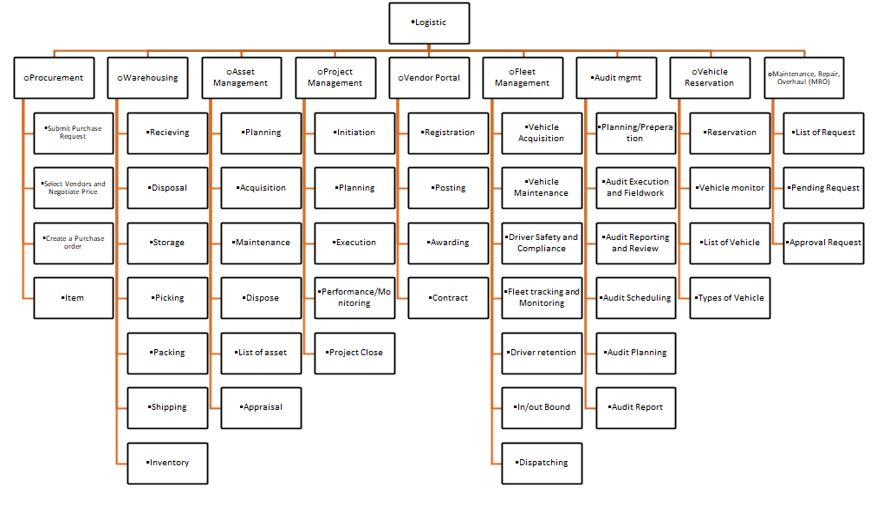

Figure : Work Breakdown Structure

### Scope verification

As the project progresses, the Scrum master can compare temporary project deliverables to the initial scope as described in the scope statement, WBS, and WBS language. After the Scrum master ensures that the scope meets the requirements defined in the project setup, the Scrum master and Sponsor can meet for official approval of the delivery. At this presentation, the Scrum master can present the deliverable to the Project Sponsor for official acceptance. The Project Sponsor can consent to the deliverable by signing a project deliverable acceptance paper. This may help to ensure that project work is completed within the project's scope on a continuous basis.

### Scope control

The scrum team can work together to keep the project's scope under control. The scrum team can make use of the WBS by using each WBS element as a work announcement. The project team may make sure that they only complete the work that is stated in the WBS and that they generate the deliverables that are specified for each WBS component. The scrum master may oversee the scrum team and, as a result, the project's progress to ensure that this scope management technique is followed. If a change to the project scope is required, the technique for suggesting scope alterations should be abandoned. Any project team member or sponsor can request changes to the project scope. All change requests should be delivered to the Project Manager in the form of a project change request document. After that, the Scrum master can assess the situation.

# Project Execution plan

## Implementation and migration plan

### Purpose

The Implementation and Migration Plan's goal is to maintain track of each system's performance and maintenance in order to increase productivity and make a firm run more smoothly. The goal of this implementation and migration plan is to outline how the Service Management Logistics project is set up, implemented, and transferred into its operational environment. The purpose of this project is to inform all stakeholders of the details, requirements, and responsibilities involved in completing the project and delivering the product to the operating group. Any suggested changes to the project must be implemented through the project change control process prior to evaluation and approval.

### Description of implementation

Because the company's current maintenance logistics systems are insufficient for expansion work, a Logistics Project will be undertaken to replace them. The implementation of this database is a deliberate and highly technological endeavor. This implementation description provides a clear picture of how the project will be implemented for all stakeholders.

### Points of contact

The table below lists all stakeholders and their points of contact in the event that they have any urgent inquiries or concerns.

|  |  |  |
| --- | --- | --- |
| **Name** | **Roles** | **Contact information** |
| Mr. Khristian Hosena | Project Sponsor |  |
| Barcinal, Marc Julius | Scrum Master |  |
| Cabiling, Romel B. | System Analyst |  |
| Malang, Eunique Lamber | System Designer/Front-end Developer |  |
| Ramos, Ronalyn M. | Front-end Developer / Business Analyst |  |
| Lesigues, Fridalyn T. | Front-end Developer / Document Expert |  |

Table 13: Points of Contacts

### Major task

The Scrum Team identified all Major Tasks required for successfully executing and migrating the Logistics Project in Tech-Trendz Human Resource. All of the Major Tasks have been double-checked by the Scrum Master, and persons or groups have been assigned to each task. As a result, the project will stay on track and will be communicated to stakeholders in a clear and concise manner. The following is the Major Task for the Logistics Project: Implementation and Migration Plan:

1. **Complete Logistics Design:**

This task implies the conclusion of all system design works for the new Web-based System.

1. **Complete Testing.**

This task indicates the requirements of the system, which is the installation of a computer, software application, and internet service.

1. **Initial implementation:**

This task indicates the beta testing of the system in the business operation. This will include the calibrating of functionality and adjustment of the system based on the evaluation.

1. **Full Implementation:**

This task indicates the training and coaching of personnel on proper handling of system and maintenance, including the capturing of existing data to the new database of the system.

1. **Launching of the system: Logistics Scrum Team and CCS Department.**

This task represents the official launch of the system into the business operation.

1. **Project Acceptance: CCS Department and Project Owner.**

This task involves formal acceptance of the Logistics Project and other project deliverables by the Project Owner and CCS Department.

### Implementation Schedule

The table below depicts the Logistics Project's implementation schedule. The above-mentioned Major Tasks are included in this schedule to keep the scrum team and stakeholders informed.

|  |  |
| --- | --- |
| **Major Task** | **Target Date** |
| Complete Logistics Design | TBA |
| Complete installation of devices | TBA |
| Initial implementation | TBA |
| Full Implementation | TBA |
| Launching of the system | TBA |
| Project Acceptance | TBA |

Table 14: Implementation Schedule

### Security

Information security measures will be established and implemented by the CCS department. The logistics database will be protected by the present firewall and security procedures of the CCS department's security administrator. While historical systems will not have any additional or unique security features, the security manager will be involved in all aspects of design, testing, implementation, and migration.

### Implementation Support

In order to execute the project's tasks, the Scrum Master will facilitate all meetings and discussions. To do these tasks, the Scrum Master will collaborate with both the administrative and CCS departments. The CCS department constructs, tests, and installs the database on both the test server and the maintenance server based on the perspectives and needs of the operations and maintenance group. The CCS department also prepares and trains maintenance. The database's lead and helper operators are in charge of this task. The Management Operations Group provides all operational needs for the database's design and implementation to the CCS group. The maintenance operations group should also contribute to the test. All of the maintenance managers are also involved. If further support is required in database education, it is integrated with the Product Owner.

### Listing of hardware, software, and facilities

Tech-Trendz Logistics necessitates a database architecture based on the service management system platform rather than the current database's location. This improves functionality and capacities without requiring further hardware or software changes. As a result, no additional infrastructure is required to complete the project's implementation and migration. This project will be carried out within the company's present capabilities

### Performance Monitoring

The database and Logistics share the same characteristics. However, there are some more features. As a result, the design team included these extra features in the Supply chain Database Performance Monitoring supply/product. In order to achieve this goal, additional monitoring criteria were applied to the manufacturing environment when the database was migrated to capture real-time data. Maintenance Operations Leads can track performance and provide weekly reports for CCS leaders and senior executives at the company. If database performance exceeds acceptable limitations, the problem is immediately escalated to staff, who determine and implement corrective actions as well as the root cause.

### Implementation Requirements (Hardware/Software/ Personnel/ Facilities/ other capital investment:

The stakeholders have concluded the requirements collection process for the Logistics Project. Despite the fact that this is a medium-sized project, the shortage of resources has an impact on its implementation. As a result, the institution will require outside assistance to complete the project. The conditions for a successful implementation of the logistics Project are listed below.

* Hardware/Software:
  + Laptop or Desktop
  + Internet Connection
* Personnel:
  + Scrum Team
* Facilities
  + None - Existing workspace will be utilized

### Back Out Plan

When preparing a database installation, we recognized the possibility of a new database failing as soon as it started on a Tech-Trendz administration management server. The scrum team designed a contingency plan to limit this risk, allowing the maintenance crew to continue working even if the system is not turned on. As the data information task advances, all maintenance data for both the database and the maintenance database is updated. The deprecated database is preserved on the service server until the checkout database is produced and operationally accepted. When the system starts up, and a fault or malfunction is detected, the developers instantly remove all maintenance. Technicians can access the old database and restore access to it, allowing repair work to continue while the logistics are being fixed and tested.

### Post Implementation Verification

Many steps will be carried out after the system has been deployed to guarantee that it is functioning effectively. First and foremost, operations management will ensure that the assigned maintenance specialist has access to the database in order to do the assignment. Managers will make sure that their database maintenance methods assess their ability to complete all assigned tasks in the database, as well as that the appropriate rights and actions are in place once this has been verified.

# Project Closure

## Transition-out plan

### Executive Summary

The process of migrating the Logistics System's authorities, duties, activities, and tasks, tool functions are formally documented in this plan. It explains how to work, and workers are transitioned out of the Logistics System. Tech-Trendz Human Resource will be able to integrate other systems in the Service Management System into a unified system using this Logistics system. This business project is presently in progress and will be completed according to the project advisers' timeline.

### Transition Approach

In this situation, the Development Team can offer the system and pass it on to the Planning process. Employees will assess the program, while the development team will assure its dignity, functionality, and troubleshooting. It will take 30 days to complete the transfer. Prior to the change, the Planning process will take a stance, and the Researcher Team will handle all of the details required for a smooth transition.

### Transition Team Organization

The table illustrates the team members in charge of the Logistics system transition, as well as their roles and responsibilities.

|  |  |  |
| --- | --- | --- |
| **Name** | **Title** | **Role/**  **Responsibility** |
| Barcinal, Marc Julius | Scrum Master | By overseeing complex projects from inception to completion.  Initiating, Planning, executing. Monitoring and Controlling, Closing. |
| Ramos, Ronalyn M. | Business Analyst | We are putting business's thoughts and goals in front of the stakeholders. |
| Malang, Eunique Lambert | System Support | Monitor and maintain computer systems and networks. |
| Lesigues, Fridalyn T. | Technical Support | Providing technical support to clients in person and remotely. |
| Cabiling, Romel B. | Process Improvement | We are deciding on the best methods to make those changes.  Identifying, analyzing, and improving upon existing business processes within an organization for optimization and to meet new standards of quality. |

Table 15: Transition Team Organization

### Work Transition

All employees will continue to work in their current positions throughout the duration of the contract transition. Employees of Tech-Trendz Human Resources shall remain on standby till the transfer is complete with carrying out their transition obligations. The assignment has been finished and acknowledged by all stakeholders. The development team will provide a workspace for all topics concerned until the transition is complete.

### Work Execution during Transition

Throughout the transition of this agreement, Tech-Trendz Services will continue to conduct work in accordance with the project timeframe and work breakdown structure (WBS) in place. The transition management team will guarantee that Logistics personnel collaborate with Tech-Trendz Human Resource counterparts, but Tech-Trendz Human Resource will retain total accountability for duties and tasks. After the 90-day transition period and transition approval, Logistics 2 will assume full responsibility for all tasks and deliverables.

### Subcontracts

The table shows the subcontractors that will fulfill the implementation requirements of the Logistics system in Tech-Trendz Services.

|  |  |  |
| --- | --- | --- |
| **Subcontract** | **Awarded to** | **Task** |
|  |  |  |
|  |  |  |
|  |  |  |

Table 16: Subcontracts

### Property Transition

#### Government Furnished Equipment (GFE)

As part of this transition, any GFE delivered to Tech-Trendz Human Resource under the Logistics System contract will be turned in to the authorities after the transitional time is completed and approved. As part of the GFE, the transition phase has been completed and approved. GFE includes laptop computers, all PEDs, flash and external hard drives, and employee ID badges. Government IT personnel will re-image all electronic gadgets and provide them to Logistics staff as new.

#### Incumbent Owned Equipment

All incumbent-owned devices will be preserved by the appointee when the transfer is completed and approved. Laptop computers, organizational tools, organizational process maps, firm ID badges, and other items are included in this equipment. If it is determined that any incumbent-owned equipment must remain with the customer in order for the agreement to be successful, the customer and incumbent contracting officer representatives will coordinate the equipment's procurement through the customer's established procurement management process.

#### Intellectual Property

All intellectual property that is a direct result of work on the contract deliverables will be migrated to the next contractor to enable the successful completion of the logistics System contract. Because intellectual property is factored into contract pricing, any resulting intellectual property will be owned by the customer.

#### User Accounts and Passwords

Multiple user account accesses and authorizations must be created and withdrawn as part of the contract transfer. Employees listed in the table below have current access to the user accounts and the system needed to complete contract deliverables. On the first day of the contract transition phase, the mentioned Tech-Trendz personnel will be provided access. All official user accounts will be disabled once the transfer is complete and approved.

|  |  |
| --- | --- |
| **User Account** | **Tech-Trendz** |
| Super Admin | dev.admin@techtrendzph.com |
| Administration | admin@techtrendzph.com |
| Logistics Manager | logistics@techtrendzph.com |
| Officer | Id_number@techtrendzph.com |

Table 17: User Accounts and Password

### Knowledge Transfer

During the 30-day transition time for this shift, knowledge will be transferred. Knowledge will be transferred using a variety of approaches. These discussions will concentrate on specific IT challenges pertaining to database responsibilities and operations. In addition, the chosen Scrum Master will work with the elected Administrator. Documentation requirements, as well as organizational procedures and assets, will be covered in these sessions. These sessions must be completed at least 20 days before the 30-day transition period ends. Furthermore, all employees will work at a rapid speed for the duration of the 30-day period to become familiar with the database, tools, processes, and organizational assets.

### Schedule

### Handover and Acceptance

When all transition-related actions have been accomplished, the client's transition email will employ the specified transition checklist. The client's project sponsor and the company's human resources director will sign and approve the checklist and supporting documents. The transition will not be considered complete until all of these approvals and signatures have been acquired.

## Project acceptance

The Scrum Master is authorized to complete the project's formal closeout. A post-project evaluation, documentation of lessons learned, the release of the Scrum Team, closing out all procurements, and archiving all pertinent project records are all part of the closeout process. The Project Sponsor will be contacted once the closing procedure is complete, and the Scrum Master will be dismissed from the project

Project Owner Acceptance

Approved by the Project Owner:



**KHRISTIAN M. HOSENA**

__________________________________ Date: ________________

(Signature over Printed name).

## Post project review

### Project Summary

The Tech-Trendz logistics project’s purpose is to improve collection report creation. This project satisfies the demand for speedier car services while also making collecting reports simple to generate. The project deliverables include system design, full coding, testing, deployment of an integrated system for usage with current IT infrastructure, and a user's guide. The logistics project aims to improve vehicle and document services, make collecting reports easier to prepare, automatically tally amounts, and provide reporting functions.

#### Project Team and Staffing

The Tech-Trendz Services consisted of a skilled and knowledgeable team.

The chart below provides information about Tech-Trendz team members:

|  |  |  |
| --- | --- | --- |
| **Name** | **Role** | **Contact** |
| Mr. Khristian Hosena | Project  Sponsor |  |
| Barcinal, Marc Julius | Scrum Master |  |
| Cabiling, Romel | System Analyst | [romelcabiling22@gmail.com](mailto:romelcabiling22@gmail.com) |
| Malang, Eunique Lambert | System Designer / Front-end Developer |  |
| Ramos, Ronalyn | Business Analyst / Front-end Developer | [ronalynramos060816@gmail.com](mailto:ronalynramos060816@gmail.com) |
| Lesigues, Fridalyn | Documentation / Frontend Developer |  |

Table 18: Project Team and Staffing

SMS project team members completed the project successfully using standard project management procedures. The scrum team had a matrixes organization with strong managers and senior leadership on board. Effective communication, thorough planning, neutral participation, project management tools, and structure all play important roles in the project's success.

#### Project Deliverable (Planned vs. Actual)

#### Transition to Operations

Transitioning to a new technological endeavor to modernize the running of any industry, such as Tech-Trendz Human Resource, can be difficult.

The Scrum Team ensures that all stakeholders and the Project Owner communicate effectively throughout the project's duration to preserve continuity after the handover.

Because of effective communication and preparation, the Logistics Project was able to transition to operation effectively. The Project Owner, CCS department, and other stakeholders will be responsible for ensuring that a new web-based system can effectively transition to an operational environment.

It is possible to improve future projects by involving operations staff early in the project design phase and requesting feedback on critical operational elements. As a result, the system's transition to business operations went off without a hitch. If operations staff had not been engaged as stakeholders or involved in project planning, this stage would have occurred later. This would have caused the project to be delayed and would have resulted in higher costs.

### Project Costs

The budgeted price for the Tech-Trendz Human Resource Project was established at this amount, which was separated out per project innovation in the chart below, with actual pricing compared to the planned/budgeted price.

|  |  |  |  |
| --- | --- | --- | --- |
| **Project Phase** | **Budgeted Cost** | **Actual Cost** | **Comments** |
| Product Design | 20,000 | 20,000 | Product Design costs were on budget |
| Testing | 20,000 | 20,000 | Testing costs were on budget |

Table 19: Project Costs

The Logistics Project's overall actual costs came to a total of. This project not only met all of its objectives and deliverables, but it also allowed the project team to allocate ₱40,000 to other vital efforts by finishing under budget. Refinement of the finished product as desired. The expenditures were sufficient for the whole budget, according to the budget.

### Project Schedule

This section explains the project's start-to-finish schedule or timeframe, as well as how the project performed against it. This information is useful in determining what factors may have contributed to project delays or allowed the project to finish early or on time. This might then be used by team members on subsequent visits or documented by other project groups for future visits. One of the most effective ways for a company to improve its project management methodologies and effectiveness is to archive project data throughout the project closure phase.

|  |  |  |  |
| --- | --- | --- | --- |
| **Project Phase** | **Scheduled Completion** | **Actual Completion** | **Comments** |
| Project Plan | TBA | Ongoing | Ongoing |
| Design | TBA | Ongoing | Ongoing |
| Coding | TBA | Ongoing | Ongoing |
| Testing | TBA | Ongoing | ongoing |
| Implementation | TBA | Ongoing | ongoing |
| One Transaction | TBA | Ongoing | ongoing |
| Project Clouse | TBA | ongoing | ongoing |

Table 20: Project Schedule

### Recommendations

# Technical solution design

## Project Information

|  |  |
| --- | --- |
| **Name** | Tech-Trendz Services  (Tech-Trendz Logistics) |
| **Description** | A system for assessing, training, and honing each employee's potential and skills for their specific professional path. |
| **Business Owner** | Mr. Khristian Hosena |
| **Objective** | To provide a streamlined way to manage staff competency, learning and training development, and an information platform that is easily accessible. |

Table 21: Project Information

## Executive Summary

## Requirement Definition

## Solution Description

### Logical Architecture

### High-Level Architecture

### Process Flow

## Implementation Timeline

# System architecture

## Business Process Architecture

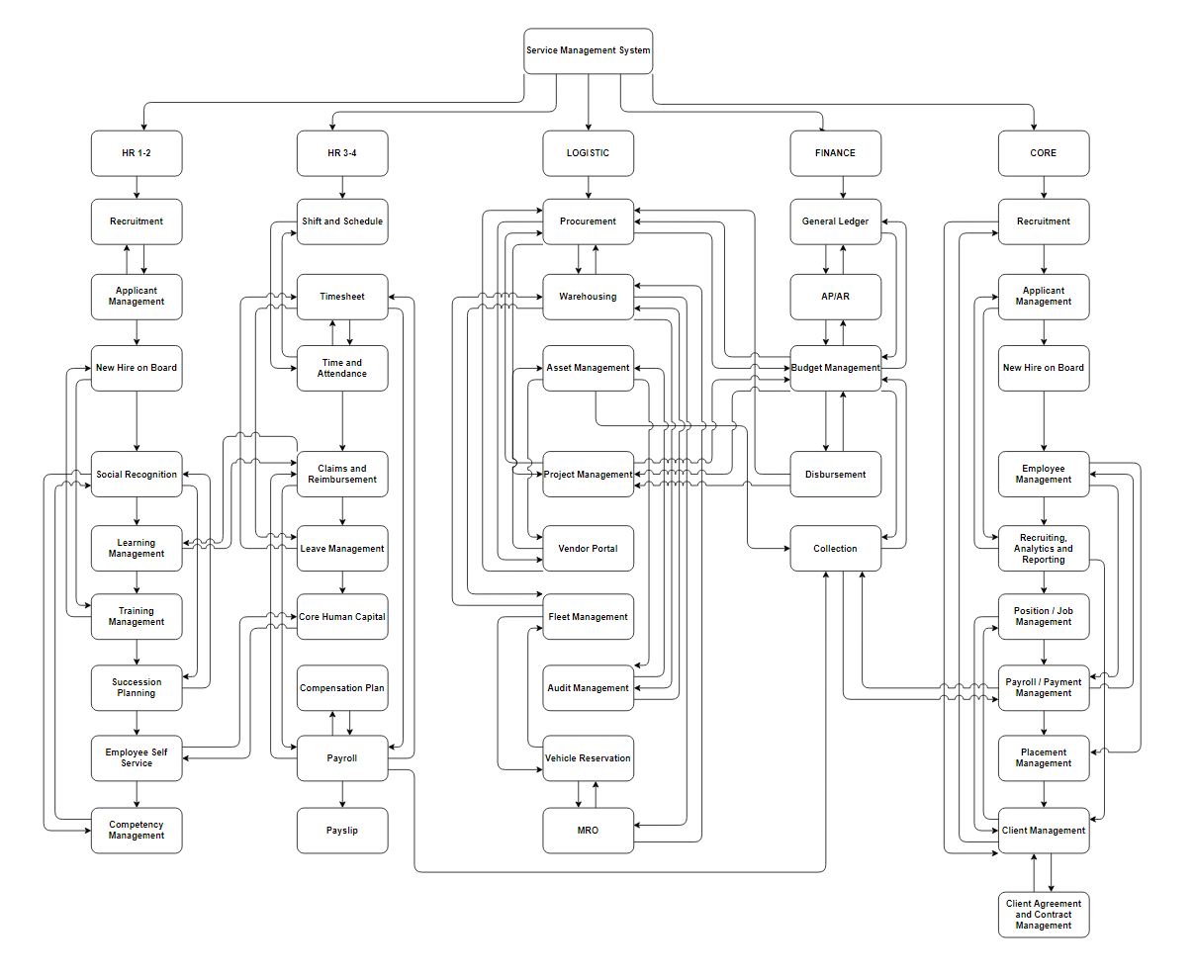

Figure : BPA Top Level 1 Service Management System

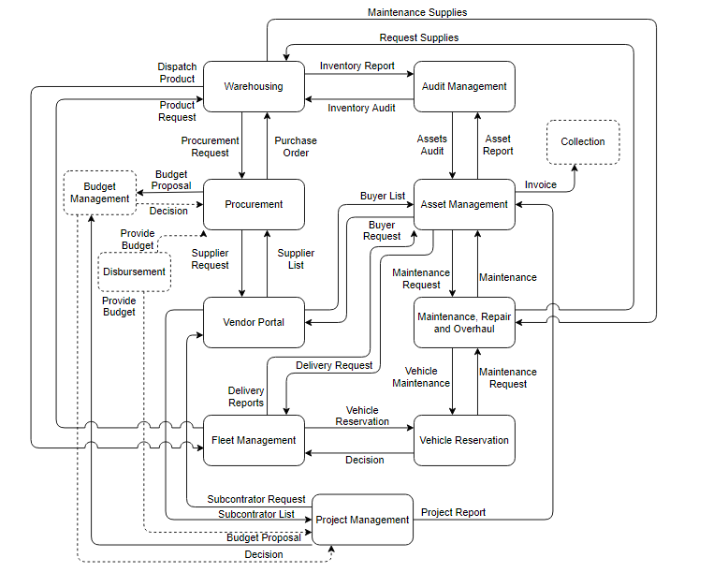

Figure : BPA Top Level 2 Logistics

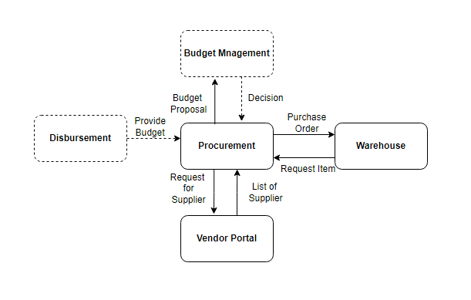

Figure : BPA Top Level 3 Procurement

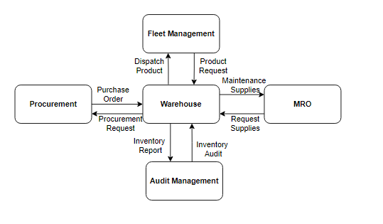

Figure : BPA Top Level 3 Warehousing

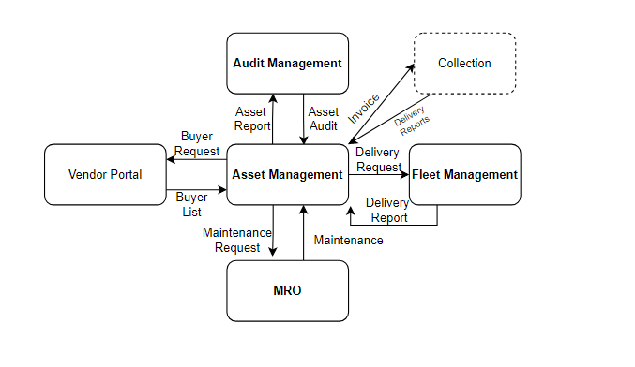

Figure : BPA Top Level 3 Asset Management

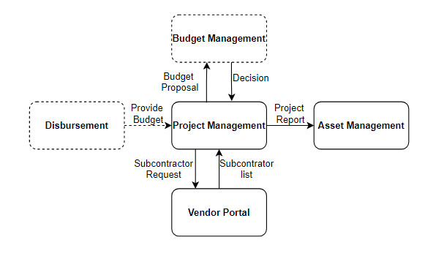

Figure : BPA Top Level 3 Project Management

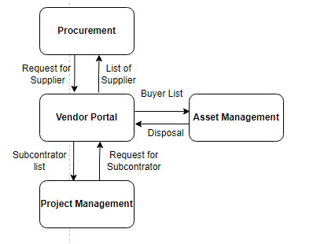

Figure : BPA Top Level 3 Vendor Portal

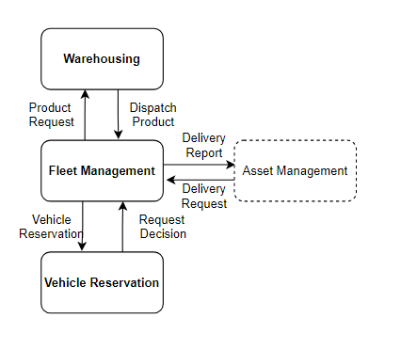

Figure : BPA Top Level 3 Fleet Management

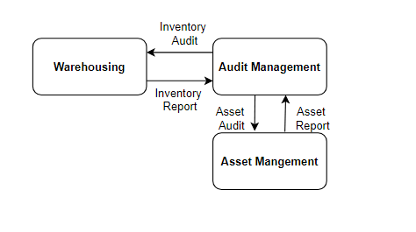

Figure : BPA Top Level 3 Audit Management

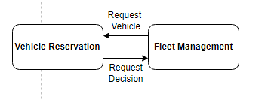

Figure : Vehicle Reservation

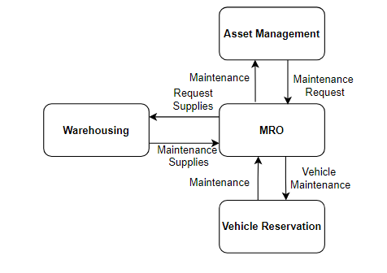

Figure : BPA Top Level 3 Maintenance Repair and Overhaul

## Application Architecture

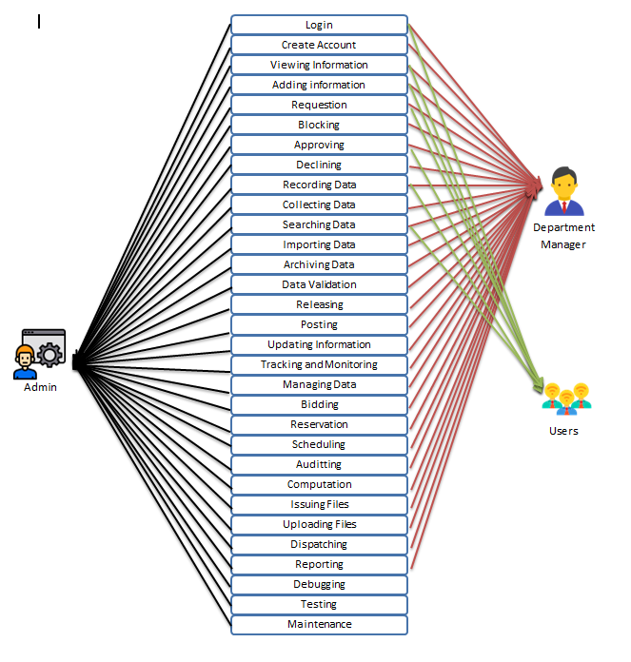

Figure : Application Architecture

## Data Architecture

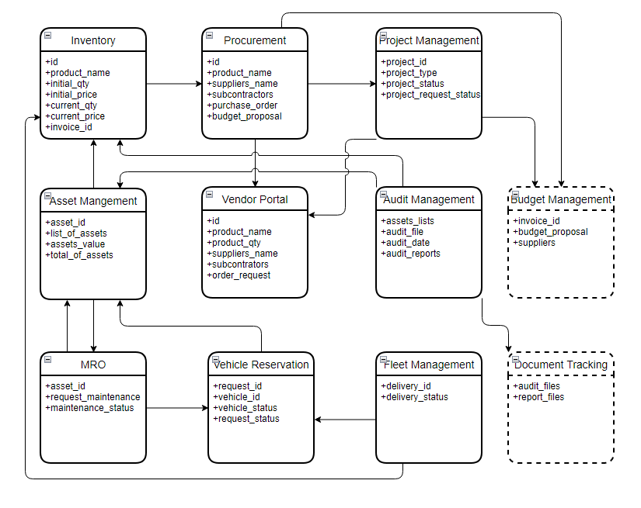

Figure : Data Architecture

## Technology Architecture

|  |  |
| --- | --- |
| **Title** | **Description** |
| HTML 5 | * HTML is a luxury language that allows internet druggies to produce and organize sections, paragraphs, and links using factors, markers, and attributes. HTML, on the other hand, isn't a programming language because it lacks dynamic capabilities. HTML can be used for many different things, including web development. |
| Description: css3, original, wordmark, logo Icon  CSS 3 | * To construct and format a satisfying structure, CSS3 is combined with HTML. Colors, fountain parcels, textbook alignments, background images, plates, tables, and so on are all handled by it. It allows for the placement of colorful particulars using fixed, absolute, and relative values. |
| Description: Web Design and Development Course : ITRA  BOOTSTRAP 5 | * Bootstrap is a prominent front-end framework for building cutting-edge websites and apps. It's open-source and free to use, yet it still includes a ton of HTML and CSS templates for UI basics like buttons and forms. Bootstrap also supports JavaScript extensions. |
| Description: Laravel - Wikipedia  LARAVEL | * Laravel is a declarative web framework with a tempting syntax. We believe that development should be an affable and creative experience in order to be truly significant. |
| Description: Logo Mysql PNG images, Free Download - Free Transparent PNG LogosMYSQL | * MySQL is a database operation system that's extensively used. |
| Description: Ubuntu icon Logo PNG Transparent & SVG Vector - Freebie Supply  UBUNTU | * • Ubuntu is a Linux distribution that is predicated on open source and privately available software. Ubuntu is available in three performances for Internet-connected bias and robots Desktop, Garcon, and Core. |
| Description: Composer - Free brands and logotypes iconsCOMPOSER | * Composer is an operation-position reliance director for PHP. Dependency basically indicates that your operation is reliant on certain libraries or packages. |
| Visual Studio Code | * VS Code or (Visual Studio Code) is a source-code editor for Windows, Linux, and macOS. Debug, syntax push, intelligent entire, grained, rule refactoring, and coverlet Git are among the features |
| GitbashDescription: Using git commands on Windows | * Git Bash is a Microsoft Windows application that functions as a Git command line emulator. |
| PHP | * . In reality, a PHP Function element is an applicable computer program that accepts parameter lists and returns a value. There are thousands of erected- features in PHP. |
| Description: JavaScript Logo  Javascript | * In JavaScript, a function is similar to a procedure — a series of words that performs tasks or calculates a value — but a procedure must accept some input and return an affair with some apparent connection between the input and the affair to qualify as a function. |
| Description: XAMPP Logo Vector (SVG, PDF, Ai, EPS, CDR) Free Download - Logowik.comXAMPP | * A particular tool is used to defend the product's most vital components. XAMPP can also produce and manipulate databases in MariaDB and SQLite, among other databases. |
| Description: Application server Computer Icons Web application Computer Servers, world  wide web, text, logo, web Application png | PNGWingAPACHE | * Accepting directory( HTTP) requests from Internet druggies and furnishing them their needed information in the form of lines and Web runners is Apache's responsibility. |
| .TDescription: TECH domains | GitHub Student Developer PackECH | * The Domain Name System (DNS) uses the technology as a general top- position sphere(gTLD). Technology is shortened in the name. |
| Let’s Encrypt | * Let's Encrypt is a freeware TLS/ SSL instrument that delivers instruments to any client who is compatible via the Automatic Certificate Management Environment or (ACME) protocol. These gadgets can translate the interaction between your online garcon and your druggies. |
| Digital Ocean | * Digital Ocean, Inc. is an American pall structure establishment. |
| NGINX | * NGINX is an open-source web garçon, rear deputy, hiding, cargo balancing, videotape streaming, and other operations. It began as a web garçon that was optimized for speed and stability. |
| Description: Laratrust - Roles & Permission Management - Made with LaravelLARATRUST | * " Adding places, rights, and platoon authorization to Laravel is simple and flexible with Laratrust." |
| GITHUB | * • GitHub, INC. is a software development and interpretation control establishment that offers Git hosting. |

Table 22: Technology Architecture

# Product Backlog

## Product backlog (user stories) Table

|  |  |  |  |
| --- | --- | --- | --- |
| **No.** | **User Stories** | **Priorities** | **Status** |
| **Procurement** | | | |
| 1 | As a procurement officer, I want to view procurement requests from other departments so that I can get informed of what items need to be procured.  *Create a request table list.* | 1 | Ongoing |
| 2 | As a procurement officer, I want to view all the supplier details approved by the vendor portal so that I can get informed of what the suppliers offer.  *Create a table list of supplier details.* | 1 | Ongoing |
| 3 | As a procurement officer, I want to be able to create a purchase order so that I can send it to the supplier.  *Create a form for a purchase order.* | 2 | Ongoing |
| 4 | As a procurement officer, I want to have a list of procured items so that I can see all the items that our department purchased.  *Create a table list of procured items.* | 3 | Ongoing |
| 5 | As a procurement officer, I want to send a budget proposal to budget management so that I can have the budget to procure items.  *Create a budget proposal form.* | 2 | Ongoing |
| 6 | As a procurement officer, I want to send a request for suppliers to vendor portal, so that I can find suppliers for items that we need to procure.  *Create a supplier request form.* | 2 | Ongoing |
| 7 | As a Procurement Officer, I want to be able to create a report so that I can keep records of our activities.  *Create a Procurement Report form.* | 4 | Ongoing |
| **Warehousing** | | | |
| 8 | As a warehousing officer, I want to know the information on our stocks; so that I can monitor what items we have and determine what items are needed to be procured.  *Create an inventory table.* |  | Ongoing |
| 9 | As a warehousing officer, I want to view item requests from other departments so that we can provide what items they need.  *Create a request table list.* |  | Ongoing |
| 10 | As a warehousing officer, I want to send a request for supplies to the procurement department so that I can maintain the inventory stocks.  *Create a form for procurement requests.* |  | Ongoing |
| 11 | As a warehousing officer, I want to be notified if we are having a product shortage so that I can send a request for supplies.  *Create a notification function.* |  | Ongoing |
| 12 | As a warehousing officer, I want to be able to add products to the inventory table so that I can add new products to our list.  *Create add function on the inventory table.* |  | Ongoing |
| 13 | As a warehousing officer, I want to be able to search products from our inventory so that I will be able to find specific products more easily.  Create a search function on the inventory table. |  | Ongoing |
| 14 | As a warehousing officer, I want to be able to edit the inventory so that I can update it whenever some changes occur.  *Create an update function on the inventory table.* |  | Ongoing |
| 15 | As a warehousing officer, I want a sort function on the inventory table so that I can sort out the items on the inventory for different categories.  *Create a sort function on the inventory table.* |  | Ongoing |
| 16 | As a warehousing officer, I want to be able to create an Inventory report so that I can send it to other departments.  *Create a form for the inventory report.* |  | Ongoing |
| 17 | As a warehousing officer, I want to be able to dispatch items, So that we can provide the items requested from us.  *Create a dispatching module.* |  | Ongoing |
| **Assets Management** | | | |
| 18 | As an Asset Management officer, I want to have information on all the assets, so that I can track all of the assets in the company.  *Create a table for asset information.* |  | Ongoing |
| 19 | As an Asset Management officer, I want to add new assets to the table, So that I can list a new asset.  *Create an add asset function.* |  | Ongoing |
| 20 | As an Asset Management officer, I want to appraise our assets, So that I will know the market value of our assets.  *Create an asset appraisal module.* |  | Ongoing |
| 21 | As an Asset Management officer, I want to monitor the depreciation of our assets, So that I can take actions based on our asset’s depreciation rate.  *Create an asset depreciation module.* |  | Ongoing |
| 22 | As an Asset Management officer, I want to generate a report regarding our assets, so that we can have it for record-keeping and send it to other departments.  *Create an asset information report form.* |  | Ongoing |
| 23 | As an Asset Management officer, I want to send a request for the buyer to the Vendor portal, So that I can sell items for disposal.  *Create a buyer request form.* |  | Ongoing |
| 24 | As an Asset Management officer, I want to generate an invoice, So that we can send it to our asset buyer and liquidate the assets that are bought from us.  *Create a form for an invoice.* |  | Ongoing |
| 25 | As an Asset Management officer, I want to send a request for the delivery to fleet management, so that we can give the sold items for disposal to the buyer.  *Create a form for delivery requests.* |  | Ongoing |
| 26 | As an Asset Management officer, I want to be able to create a disposal report, so that we can have it for record-keeping.  *Create a form for Disposal Report.* |  | Ongoing |
| 27 | As an Asset Management officer, I want to view all reports regarding the company’s assets that another department manages, so that I can compile and keep records of them.  *Create an asset reports list.* |  | Ongoing |
| 28 | As an Asset Management officer, I want to request for inventory report, so that I can keep records of it.  *Create a form for the inventory report.* |  | Ongoing |
| 29 | As an Asset Management officer, I want to send a request for maintenance to MRO, so that our facilities as always operable and are low on depreciation.  *Create a form for maintenance requests.* |  | Ongoing |
| **Project Management** | | | |
| 30 | As a Project Management officer, I want to view all the projects, so that I can get informed on what projects are still ongoing.  *Create a table for the project.* |  | Ongoing |
| 31 | As a Project Management officer, I want to be able to add new projects, so that I can work on new projects that our company needs.  *Create and add project functions to the table.* |  | Ongoing |
| 32 | As a Project Management officer, I want to send a budget proposal to budget management, so that I can acquire the budget needed to create a new project.  *Create a form for the budget proposal.* |  | Ongoing |
| 33 | As a Project Management officer, I want to send a request for subcontractors to the vendor portal, so that I can find a subcontractor for the project.  *Create a form for subcontractor requests.* |  | Ongoing |
| 34 | As a Project Management officer, I want to view all the subcontractor details approved by the vendor portal, so that I can get informed of what the subcontractors have to offer.  *Create a table list of subcontractor details.* |  | Ongoing |
| 35 | As a Project Management officer, I want to be able to create a contract, so that I can use it for agreement terms with the subcontractor and for record-keeping.  *Create a form for the Contract.* |  | Ongoing |
| 36 | As a Project Management officer, I want to know the status of our projects, so that I can monitor and track the progress of the projects.  *Create a monitoring function for the project table.* |  | Ongoing |
| 37 | As a Project Management officer, I want to generate a report detailing our project, so that I can have it for record-keeping as well as sending it to asset management.  *Create a project report form.* |  | Ongoing |
| **Vendor Portal** | | | |
| 38 | As a Vendor Portal officer, I want to view the requests from other departments, so that I can get informed of what kinds of advertisements we are going to post on our portal.  *Create a table for requests.* |  | Ongoing |
| 39 | As a Vendor Portal officer, I want to post ads looking for suppliers/subcontractors, so that I can find and list suppliers/subcontractors that want to strike a deal with us.  *Create a posting module.* |  | Ongoing |
| 40 | As a Vendor Portal officer, I want to create a list of suppliers, so that I can send it to Procurement Department.  *Create a list of suppliers.* |  | Ongoing |
| 41 | As a Vendor Portal, Officer, I want to create a list of subcontractors, so that I can send it to Project Management.  *Create a list of subcontractors.* |  | Ongoing |
| 42 | As a Vendor Portal officer, I want to post a listing for an asset for sale, so that I can find and list buyers that want to buy our assets.  *Create a vending module.* |  | Ongoing |
| 43 | As a Vendor Portal officer, I want to create a list of interested buyers, so that I can send it to Asset Management.  *Create a list of buyers.* |  | Ongoing |
| 44 | As a vendor portal officer, I want to view a list of posted ads and listings, so that I can track the items that are accomplished.  *Create a list of posted ads* |  | Ongoing |
| **Fleet Management** | | | |
| 45 | As a Fleet Management officer, I want to view delivery requests from other departments, so that I can plan out the delivery process.  *Create a delivery request table.* |  | Ongoing |
| 46 | As a Fleet Management officer, I want to view details on all of our vehicles, so that I’ll be able to know the information regarding our vehicles.  *Create a vehicle information table.* |  | Ongoing |
| 47 | As a Fleet Management officer, I want to be able to create a Vehicle Information Report, so that I can keep a record of what kinds of vehicles we have.  *Create a form for a vehicle information report.* |  | Ongoing |
| 48 | As a Fleet Management officer, I want to send a reservation request to Vehicle Reservation, so that I can secure an available vehicle for delivery.  *Create a vehicle reservation request form.* |  | Ongoing |
| 49 | As a Fleet Management officer, I want to send item requests to the Warehousing department, so that I can secure the products for delivery.  *Create an item request form.* |  | Ongoing |
| 50 | As a Fleet Management officer, I want to have a dispatch list, so that I can get informed which vehicles have already left for delivery.  *Create a vehicle dispatch table.* |  | Ongoing |
| 51 | As a Fleet Management officer, I want to know the delivery status, so that I can track and monitor the delivery.  *Create a delivery status in the table.* |  | Ongoing |
| 52 | As a Fleet Management officer, I want to generate a delivery report, so that I can record and send it to other departments.  *Create a delivery report form.* |  | Ongoing |
| **Audit Management** | | | |
| 53 | As an Audit Management officer, I want to send a request for an inventory report to warehousing, so that we can use it for our audit fieldwork.  *Create an inventory request form.* |  | Ongoing |
| 54 | As an Audit Management officer, I want to send a request for asset information to asset management, so that we can use it for our audit fieldwork.  *Create an asset information request form.* |  | Ongoing |
| 55 | As an Audit Management officer, I want to have a list of all the audit plans, so that I will know the details for our audit execution.  *Create a list of audit plans.* |  | Ongoing |
| 56 | As an Audit Management officer, I want to be able to select the dates of our audit execution, so that I can schedule when we are going to execute our audit.  *Create a schedule table for audits.* |  | Ongoing |
| 57 | As an Audit Management officer, I want to be able to create an Audit Report, so that we can have it for record-keeping.  *Create an audit report form.* |  | Ongoing |
| **Vehicle Reservation** | | | |
| 58 | As a Vehicle Reservation officer, I want to have a list of all vehicles, so that I can see what vehicles are available or not.  *Create a vehicle availability list.* |  | Ongoing |
| 59 | As a Vehicle Reservation officer, I want to view the list of reservations, so that I will know which vehicles will be needed.  *Create a table list of reservations.* |  | Ongoing |
| 60 | As a Vehicle Reservation officer, I want to have an “approve” or “decline” button on the table, so that I can give a decisive response to reservation requests.  *Create a button for approving or declining on the reservation table.* |  | Ongoing |
| 61 | As a Vehicle Reservation officer, I want to have a vehicle returned list, so that I can monitor if the vehicles have been returned or still not.  *Create a Returned Vehicle list.* |  | Ongoing |
| 62 | As a Vehicle Reservation officer, I want to know the status of our vehicles, so that I’ll be able to know if our vehicles need repairs.  *Create a monitoring function on returned vehicle list.* |  | Ongoing |
| 63 | As a Vehicle Reservation officer, I want to send a request for maintenance to the MRO department, so that I can ensure our vehicles are always operable.  *Create a form for maintenance requests.* |  | Ongoing |
| **Maintenance, Repair and Overhaul** | | | |
| 64 | As an MRO officer, I want to view maintenance requests from other departments, so that I can get informed about what assets need maintenance or repair.  *Create a request table list.* |  | Ongoing |
| 65 | As an MRO officer, I want to have an “approve” or “decline” button on the table, so that I can give a decisive response to maintenance requests.  *Add a button for approving or declining on the request table.* |  | Ongoing |
| 66 | As an MRO officer, I want to send item requests for supplies to the warehousing department, so that I can have supplies that are needed to repair our assets.  *Create an item request form.* |  | Ongoing |
| 67 | As an MRO officer, I want to schedule my maintenance activities, so that we can work more efficiently.  *Create a Maintenance Scheduling module.* |  | Ongoing |
| 68 | As an MRO officer, I want to know the status of our maintenance operations, so that I can monitor if the procedure is already finished or still ongoing.  *Create a monitoring module.* |  | Ongoing |

Table 23: Product Backlog (User Stories) Table

## Product Backlog for EIS Information Security

|  |  |  |  |
| --- | --- | --- | --- |
| **No.** | **User Stories** | **Priorities** | **Status** |
| 1 | As a product owner, I want to have a secured domain, so that our system is secured.  *Create a secured domain with SSL* | 1 | Ongoing |
| 2 | As a product owner, I want to have a secured database, so that our data is secured.  *Create security for database* | 1 | Ongoing |
| 3 | As a product owner, I want to have a backup. So that in case of emergency, we have a backup.  *Create a backup plan* | 1 | Ongoing |
| 4 | As a product owner, I want to have a secured account, |  |  |
|  |  |  |  |
|  |  |  |  |
|  |  |  |  |

Table 24: Product Backlog EIS Information Security

## Product Backlog for EIS Standards

|  |  |  |  |
| --- | --- | --- | --- |
| **No.** | **User Stories** | **Priorities** | **Status** |
| 1 | As a product owner, I want to have a login form, so that I can log in to the system.  *Create a login form.* | 1 | Ongoing |
| 2 | As a product owner, I want to create an account for my staff so that that staff can access the system.  *Add a create account function.* | 1 | Ongoing |
| 3 | As a logistics admin, I want to be integrated into other departments, so that I can do a transaction with them.  *Integrate logistics panel to other departments* | 2 | Ongoing |
|  |  |  |  |
|  |  |  |  |
|  |  |  |  |
|  |  |  |  |

Table 25: Product Backlog for EIS Standard

## UI/UX (Icons, color, etc.)

|  |  |  |
| --- | --- | --- |
| **UI** | **Icons** | **Descriptions** |
| Buttons |  | Design for all button |
| Icons |  | Design for Icons |
| Forms |  | Form Design |
| Dropdown |  | Dropdown design |
| Charts |  | Charts Design |
| Tables |  | Design for tables |
| Colors Scheme |  | Color Scheme |

Table 26: UI/UX (Icons, Color, ETC.)

## Product Backlog for integration

|  |  |  |  |
| --- | --- | --- | --- |
| **No.** | **User Stories** | **Priorities** | **Status** |
| 1 | As a product owner, I want to have an integrated dashboard from all departments, so that I can see all of the functions in the entire system.  *Create an integrated dashboard for admin.* | 1 | Ongoing |
| 2 | As a logistics admin, I want to be integrated into other departments, so that I can do the transaction with them.  *Integrate logistics panel to other departments* | 1 |  |
|  |  |  |  |
|  |  |  |  |
|  |  |  |  |

Table 27: Product Backlog for Integration

## Product Backlog for analytics

## Application System Analytics

## EIS Analytics

# Sprint backlog

## Sprint backlog table

### User stories

### Information security

### EIS standard

### EIS integration

### Analytics

## Sprint Burndown Chart

### Sprint Backlog

# EIS Implementation Model

## Information and Data Management

### Data Integration Model

### Data Migration Strategies

#### Planning

#### Data Profiling

#### Data Backup

#### Migration Design

#### Execution

#### Testing

#### Post-Migration Audit

### Data Analytics (Business Intelligence Framework)

### Privacy and Security

### Backup, Retention, and Disposal

## Information Security

### Physical Security

#### Administrative Security Controls

##### Personnel Security

##### Account Management

#### It and Security Policy

#### Technical Security Controls

##### It Infrastructure Security

##### Software Security Management

##### Cloud Security

##### Cybersecurity

#### Network Security

#### Firewall Management

#### Network Devices Security

#### Software Patch Management

#### Malware Protection

## Network Design and implementation Model

### Design Architecture

#### Hardware

#### Transmission Media

#### Protocols

#### Topology

### implementation Framework

# Conclusion and Recommendations

# Appendices:

## Appendix A Detailed System Architecture/ Reference requirements

### A.1 Business Process Architecture (Business Process Model)

### A.2 Application Architecture

#### A.2.1 UML- Use Case Diagram

#### A.2.2 UML- Detailed Diagrams

#### A.2.3 UI Navigation Diagram

#### A.2.4 UIs (Design Layout)

### A.3 Data Architecture

#### A.3.1 ERD

#### A.3.2 Class Diagram

#### A.3.3 Data Dictionary

### A.4 Technology Architecture

# Appendix B Deployment Diagram

# Appendix C Adviser Acceptance (Functional)

# Appendix D Sprint Burndown Charts (per sprint) Signed by the adviser

# Appendix D.1 Individual burndown charts per member

# Appendix B Deployment Diagram

# Appendix E Requirements Traceability Matrix (PB, Test Scenarios, status

# Appendix F Panel Evaluation and Signature (Plus photo ops during defense)

# Appendix G Pilot Companies Background with proofs of interviews

# Appendix H USB Copy of the codes (reliable USB)

# Appendix I IMRAD Format Summary

# Appendix J Comparison of the EIS to existing EIS’s (5 Pages)

# Appendix K Operation Manual (10 Pages max, 5 Pages min)

### 